Azure CLI ARM (Day 76)

On Windows

1)Install Azure CLI & Login
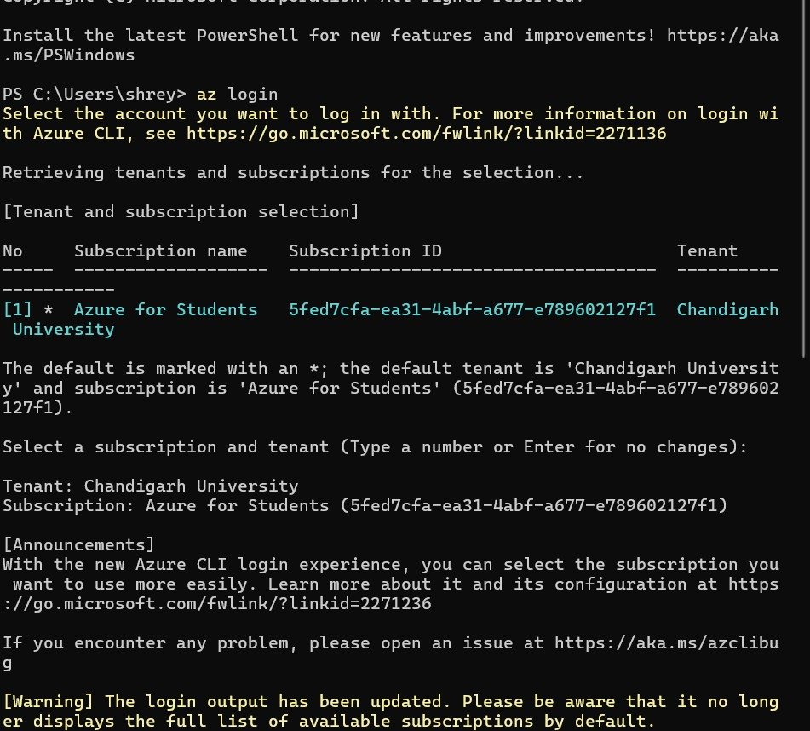
2)Create Resource Group
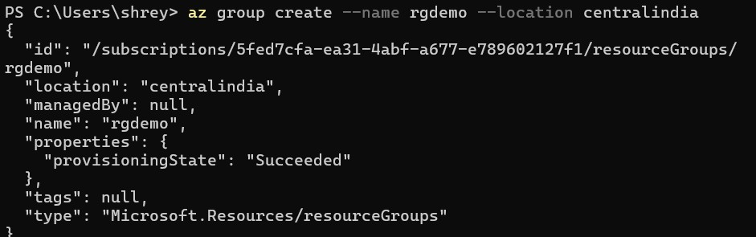

3)List Resource Group
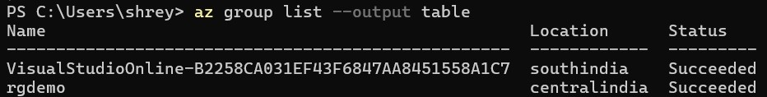

4)Output
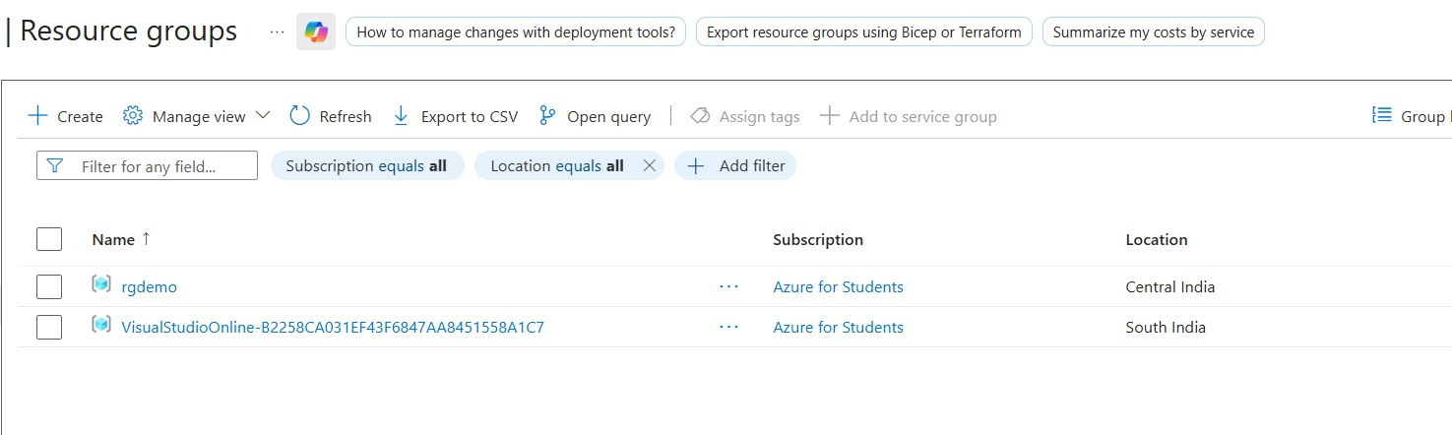
5)Deletion

On Azure Portal
1)Resource Group Creation
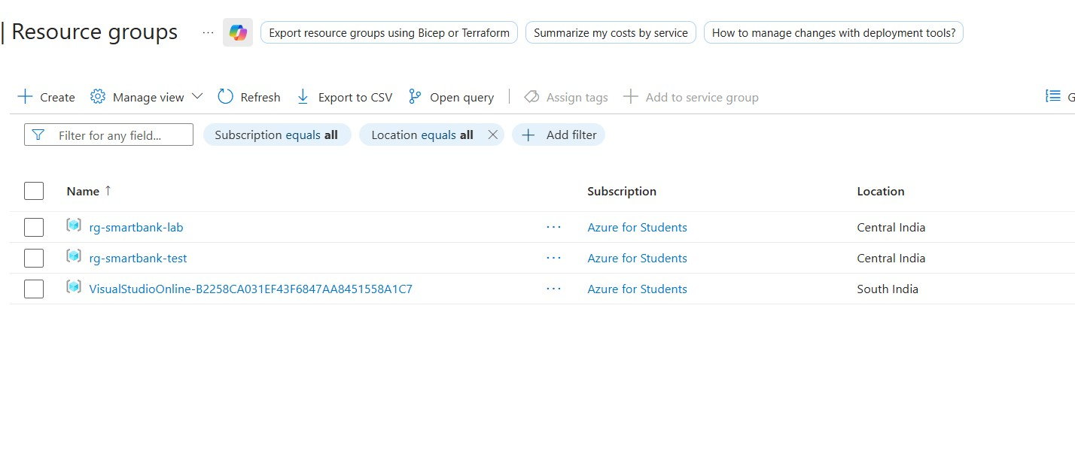

On Cloud Shell
1)Resource Group Creation
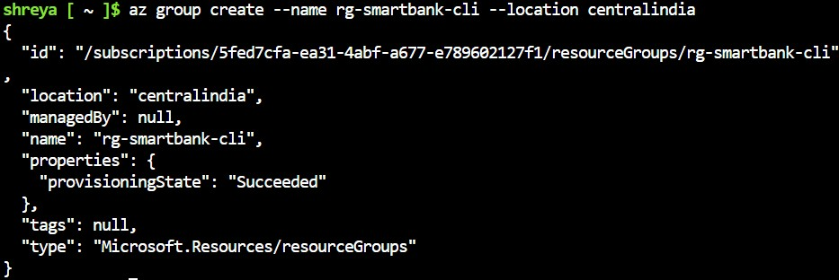
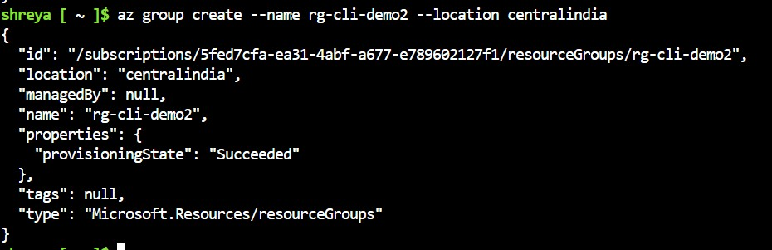
2)List Resource Groups
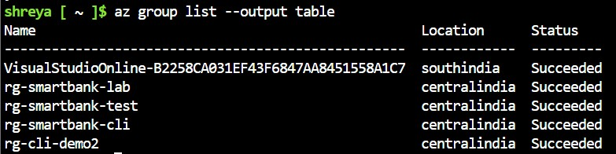
Powershell CLI
1)Resource Group Creation
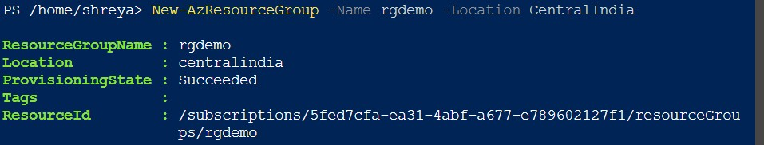
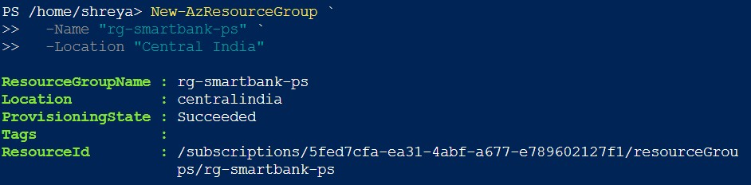
2) Get Resources
